**Lab Report:**

1. Briefly summarize the EULA of EditPad Lite. Briefly describe how EditPad is different from NotePad.

Informs the user that once they agree to the agreement, they have to use the software in the manner intended. This particular EULA is only for this edition of Editpad and cannot be used for a different program. If a software is not purchased, the user is not entitled to technical support, as the free version does not include forum functionality.

Edit pad allows for multiple tabs in window, additional text filtering options such as alphabetical sorting and different file encoding types. Also displays a tool bar with icon as quick links to open, save, save all, cut, copy, and paste.

2. What did you do to uninstall EditPad?

Opened the start menu, found the program, right clicked on the application name, selected uninstall.

3. What is the license type for LightScreen and what does it mean?

Lightscreen uses a GNU general public license. Used for free software, which allows users to modify and share the modified software.

4. How do you uninstall programs using the control panel? Briefly describe the steps.

Find the program, right click on the application name, select uninstall, follow install prompts specific to program.

5. Include a screenshot that you took at step 5 after you installed 7zip.

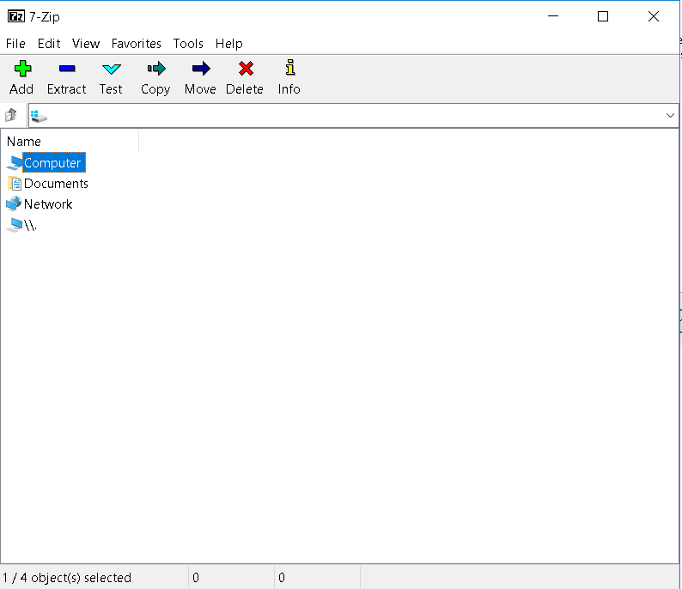

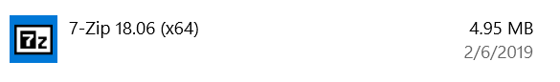

6. After you have uninstalled the programs:

Is anything left on the computer?

The installation file required run the program/ software.

How would you get rid of what is left?

Open folder where installation file was downloaded, right click on item, select delete from drop down.

Do all programs leave stuff on the machine?

You would have to select to “run” the program as opposed to “save and run”.